**E-PRTR Validation rest web service**

**-**

**Deployment manual**

|  |  |
| --- | --- |
| Date |  |
| Version | 0.1 |
| Authors | Alberto Telletxea |
| Revised by | German García de Guturbay |

index

1 Introduction 3

1.1 Purpose 3

1.2 Objectives 3

1.3 Scope 3

2 Technological Platform 4

3 Implementation instructions 5

3.1.1 Copy web service publication files into the web server 5

3.1.2 Create the Virtual Directory in the IIS7 5

3.1.3 Test the web service 9

# Introduction

## Purpose

This document aims to describe the implementation process for the E-PRTR Validation REST web service. This web service will allow the E-PRTR Validation tool validating E-PRTR XML data delivered by MS against two rules:

* Rule 4: Consistency of the National IDs reported against the E-PRTR database
* Rule 6: Consistency of the coordinates reported against the NUTS region Level II

## Objectives

* Provide the necessary instructions to allow the implementation of the Web Service
* Provide the technological platform details for the implementation

## Scope

This document encompasses the approach for meeting the requirements as defined within the document provided by Bilbomatica to ATKINS:

* **E-PRTR Validation Web Service Technical Specifications**

# Technological Platform

The E-PRTR REST web service has been developed with Microsoft .Net Visual Studio 2008. For the implementation of the web service the web server requires the following:

1. A Windows server operating system (e.g W2003, W2008)
2. .Net Framework 3.5 installed
3. Internet Information Server (IIS) as the web server software, Bilbomatica has already tested successfully the web service with IIS 6 and IIS7.

# Implementation instructions

### Copy web service publication files into the web server

The web service application contains the following files:

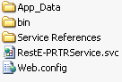

*Figure 1*

A folder has to be created in the web server inside *C:/inetpub/wwwroot/called* “E-PRTR Validation Service”:

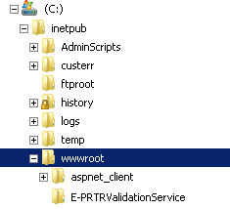

Inside this folder, web service publication files (Figure 1) should be copied.

### Create the Virtual Directory in the IIS7

The recently created folder at *wwwroot* directory should be viewed inside the Internet Information Service.

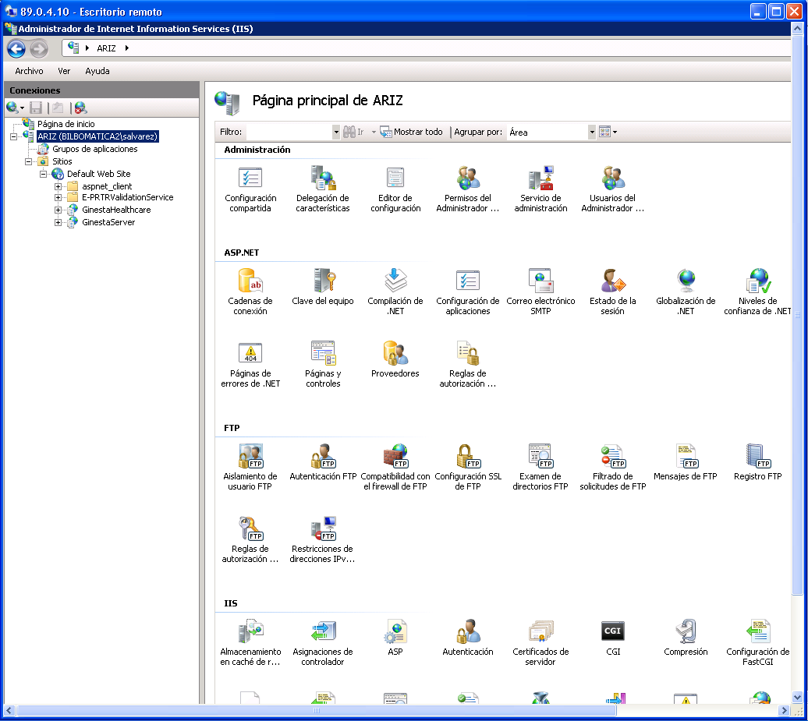

In order to create the virtual directory for web publication, right click in “Default Web Site” at IIS (right panel) and choose “Add application”. This will show the following dialog.

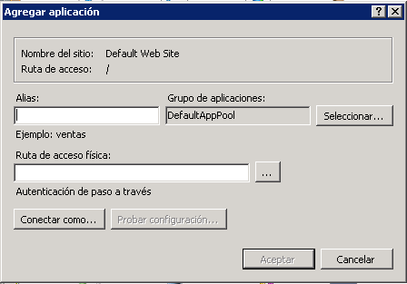

Set parameters as follows:

* Alias – Write a name for the virtual directory (e.g. E-PRTRValidationService)
* Path – Write the physical path for the web service application, in this case: C:/inetpub/wwwroot/E-PRTRValidationService.

Click “OK”.

The virtual directory will be shown as folllows in the IIS:

Click once in the virtual directory, E-PRTR Validation Service.

In the right panel of the IIS go to the “Authentication” setting window by double click in the follow in icon:



This will show the following window:

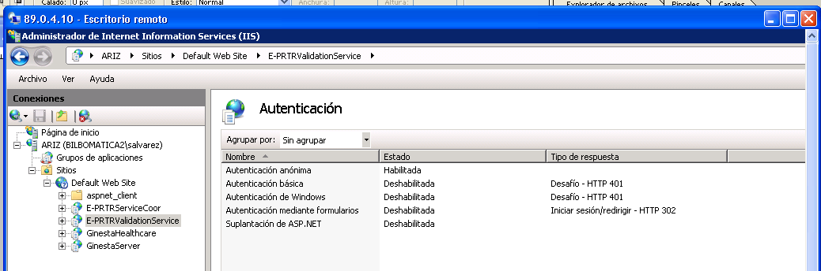

Right click in “Anonymous authentication” and enable it. The settings should be set as the above capture.

Check that the web service will be published through the port 80. Go to the left panel and click in the E-PRTR Validation service virtual directory. This will show the following:

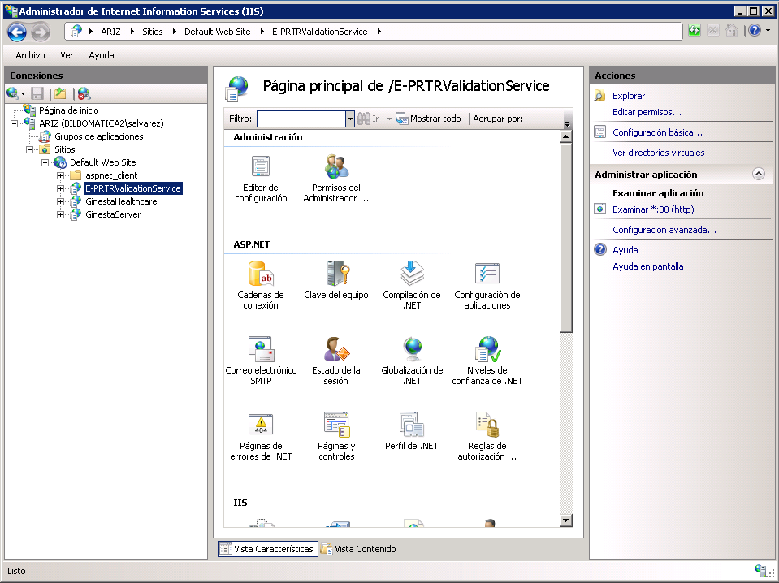

Now, the web service should be successfully published in the IIS.

### Test the web service

To test the web service is successfully published link to the following URL in a browser inside the web server:

http://localhost/E-PRTRValidationService/RestE-PRTRService.svc/Coordinates?LonCoor=16.4027431529776&LatCoor=57.0126631873995.

The web service result should be:

